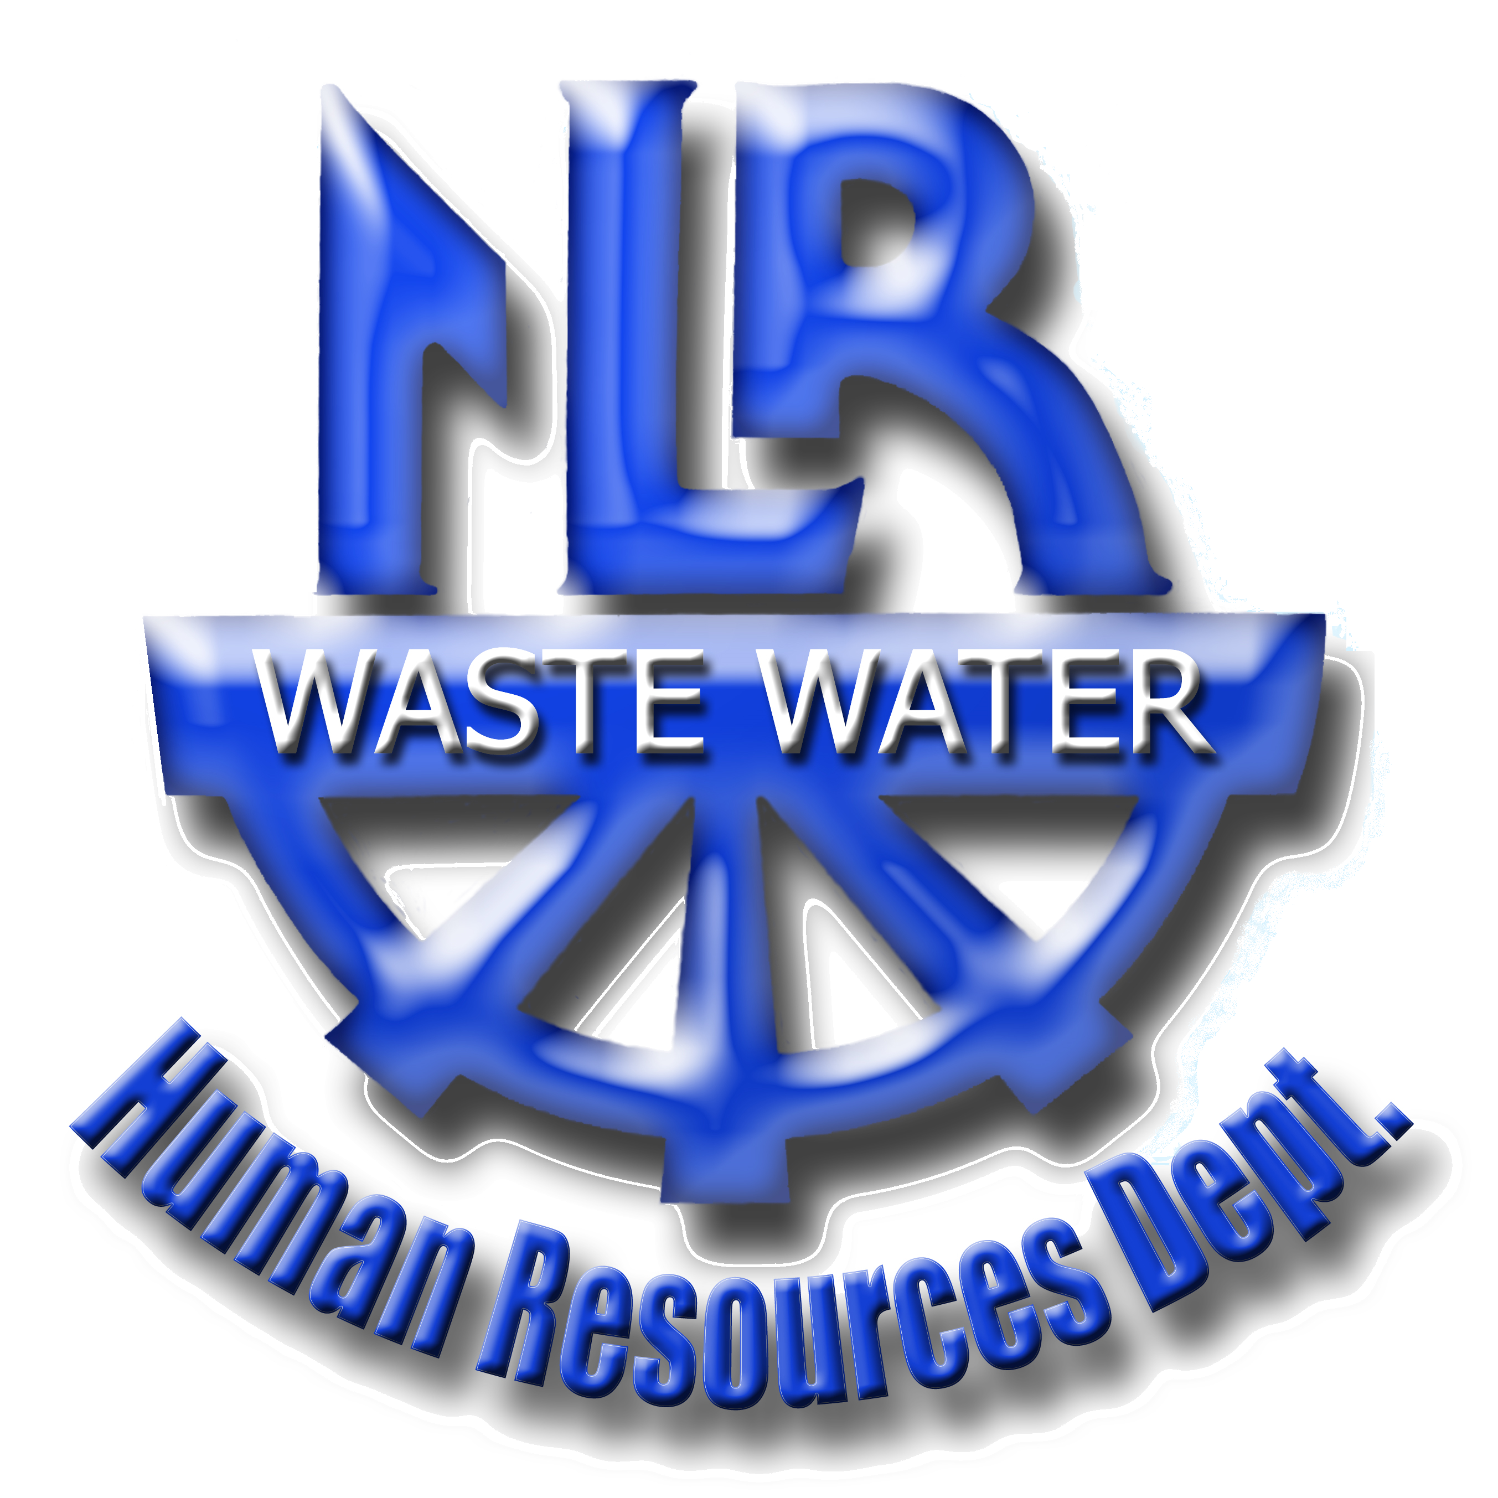
JOB ANNOUNCEMENT
ENVIRONMENTAL/LABORATORY
SUPERVISOR

Opening Date: November 26, 2018 Closing Date: Until filled
Full-Time Position Starting Salary From:$ 48,298.57 ************************************************************************************************************* MINIMUM REQUIREMENTS

- B.S. or B.S.E. or equivalent
- Extensive knowledge of Federal, State, Local Environmental Laws and ordinances
- Working Knowledge of Standards for Testing Wastewater
- Knowledgeable of BOD, COD, TSS etc. testing procedures
- Must be able to develop spread sheets on PC
- Ability to obtain a Class I Waste Water Operator's License
- Experience in supervising technical workers (Lab Techs)
- Valid Arkansas Driver's License
- Ability to lift 20 pounds
Applicants meeting the above minimum requirements will be evaluated for previous training or experience in the duties, knowledge, skills and abilities described below. Those applicants whose training and/or experience best relate to the duties, knowledge, skills, and abilities outlined below will be given first consideration for this position. Applicants will be evaluated on the length and quality of work experience of a related nature in previous positions and on other factors such as:
- Absenteeism records
- Current job performance ratings
- Reference from previous employers attesting to work habits, punctuality, and reliability
- Safe driving record
ALL APPLICANTS SHOULD BE RELIABLE, DEPENDABLE AND HARD-WORKING AND MUST HAVE THE ABILITY TO UNDERSTAND AND CARRY OUT WRITTEN & ORAL INSTRUCTIONS. APPLICANTS MUST HAVE THE ABILITY TO WORK WELL WITH SUPERVISORS, DEPARTMENT PERSONNEL AND THE GENERAL PUBLIC.
***************************************************************************************************SAMPLE OF DUTIES AND RESPONSIBILITIES:
- Ensures compliance with Federal, State, Local Laws and ordinances pertaining to Wastewater treatment process
- Determines and establishes methods/procedures for laboratory analysis.
- Setup and monitors quality assurance plan
- Oversees training of Laboratory Technicians.
- Develops spreadsheets, to calculate monthly data NPDE and DMR reports.
- Establishes budget and purchasing for the Laboratory
- Receives and reviews lab/environmental impact reports for Director
- Purchases, calibrates, maintains Telemetry Equipment for flow meters
- Approves work schedules for the lab.
- Complies with safety procedures and guidelines at all times
- Performs other duties as assigned
***************************************************************************************************APPLICANTS SHOULD SUBMIT A RESUME AND A STANDARD NLR WASTE WATER UTILITY APPLICATION FORM TO:
NORTH LITTLE ROCK WASTE WATER UTILITY'S HUMAN RESOURCES DEPARTMENT
7400 BAUCUM PIKE, P.O. BOX 17898, NORTH LITTLE ROCK, ARKANSAS 72117 APPLICATIONS CAN BE SUBMITTED ON LINE AT:
http://nlr.ar.gov/government/a_z_department_list/wastewater/wastewater_employment/
*************************************************************************************************** REMOVE FROM BOARD BY: December 30, 2018

